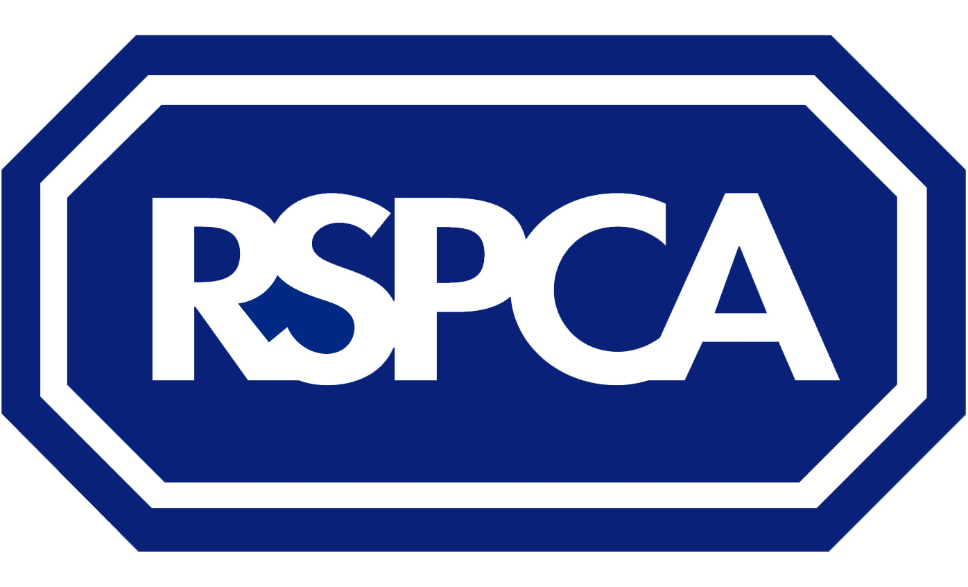
Perfect match
APPLICATION TO ADOPT A SMALL ANIMAL

Great news, you want to adopt a small animal from us! We just need to get a few details from you so we can find the perfect animal for you. Please answer honestly, so we find the right match.

A FEW DETAILS ABOUT YOU
Mr/Mrs/Miss/Ms/other Surname First name Email Address
Postcode

Best telephone number(s) to contact on
(We will normally contact you between 8am-5pm, but it may be the evening if you are applying to a branch without an animal centre.)

WHERE DID YOU HEAR ABOUT US?
- Advertisement ☐ Already aware of centre/branch ☐ Referred by owner ☐ Website ☐ Referred by other establishment
- Just passing ☐ Word of mouth ☐ NCC/RSPCA enquiries ☐ Other (please state where)

YOU ARE INTERESTED IN ADOPTING:
Species: ☐ Guinea pig ☐ Hamster ☐ Chinchilla ☐ Pet bird (please state type)
- Degu ☐ Ferret ☐ Gerbil/jird ☐ Mouse ☐ Rat ☐ Other (please state type)

Any specific gender? ☐ Male ☐ Female ☐ Either
Are you looking to adopt/foster: ☐ A single animal ☐ A pair of animals ☐ A group of animals
Have you seen an animal(s) on our website that you are interested in? If so please tell us the name and location.

A LITTLE BIT ABOUT YOUR HOME:

Do you: ☐ Own ☐ Rent If you rent, have you got written permission from your landlord? ☐ Yes ☐ No

If applicable to the animal, do you have a garden? ☐ Yes ☐ No ☐ Communal

Do you have the animal(s) accommodation already? ☐ Yes ☐ No
If yes, please describe type, including any sizes. Please give as much detail as possible:

A LITTLE BIT ABOUT YOUR FAMILY:
Who lives at home? Adults Children Children’s ages
Do you own other animals of the same species as you wish to adopt? ☐ Yes ☐ No
If yes, please state gender

If applicable, are they neutered? ☐ Yes ☐ No
If applicable, have they been vaccinated within the last year? ☐ Yes ☐ No
Do you own other pets? ☐ Dogs ☐ Cats ☐ Rodents ☐ Pet birds ☐ Other, please state

A LITTLE BIT ABOUT YOUR LIFESTYLE:

What provision do you have for cleaning out and feeding the animal, i.e. who and frequency?

Are you planning any of the following? ☐ Moving house ☐ Holiday in the next few weeks

YOUR IDEAL ANIMAL:

Have you any specific requirements of your new animal? (E.g. to like being picked up/petted, indoor animal)

This is the first animal of this species that I will have owned/fostered ☐ Yes ☐ No

Signature Date

We'd love to keep you updated about our fundraising activities, products and ways in which you can support us to help animals. Tell us how you would like to hear from us. Post ☐ Telephone ☐ Email ☐ SMS ☐

All personal information supplied by you on this application form will be processed by the Royal Society for the Prevention of Cruelty to Animals whose privacy policy is available and published at: www.rspca.org.uk/privacy or on request by calling Supporter Services on 0300 123 0346. This applies whether the information is supplied directly to the national RSPCA (charity number 219099), as data controller, or is shared with us by an RSPCA Branch (a separately registered charity) as a joint data controller. The term “RSPCA” will refer to both data controllers.

Whilst every care is taken to find the right animal(s) for you, we cannot guarantee behaviour.
Please take this form to your nearest animal centre/branch, or email if requested. Do not send to us by post, unless requested, as we cannot process postal applications.

